

PROFESSIONAL REFLECTIVE SUPPORT AND SUPERVISION
- What is it?
- How can it help?
- Is it for me?
- How can I access it?

WhAT IS Supervision?
Many professional groups who work with children and young people receive regular professional supervision to support their safe practice and create a space for reflection and growth (Hawkins & Shohet, 2006).
Within the context of local authority schools however supervision is rarely provided as a matter of course to senior managers (Lawrence, 2020).
A research project has been completed recently in Highland with a small group of head teachers. They were involved in co-creating a framework for a supervision process and then engaged with this process over a number of months.
Feedback from the head teachers, following their engagement in this research, was very positive and as a result it has been agreed to continue to offer reflective professional supervision to a wider range of practitioners.
Head teachers participating in the research said that :
- supervision improved the quality of care they gave.
- they felt less stressed after seeing their supervisor
- they were able to widen their skill base during supervision sessions.

how can it help?

Supervision enables the individual or group to think systemically and psychologically about where their feelings come from, what may lie behind the behaviours of others, what might be the emotional impact from what others carry etc.

It considers the relational aspects of professional life and helps process the emotional impact of your job role.

Supervision is not therapy or counselling, and neither is it a teaching session or line management. It is generally led by experience and the needs of the supervisee rather than being expert led by the supervisor.

With the complex social and emotional situations senior managers manage in schools, it is argued that they do need to understand emotions and relationships and how to engage in a system where they have little control over the component parts.

Supervision is a confidential, professional conversation between a skilled ‘Supervisor’ who has undergone specialist training, and a ‘Supervisee’, who has voluntarily requested to engage in the process.

The supervisory relationship is therefore critical to the success of the process. It requires the supervisor to be open, honest and build up trust with the supervisee. The supervisee also needs to be open with their practice and willing to share their views and feelings.

Supervision can be provided in-person or on-line using Microsoft Teams. A formal agreement (contract) is used to establish the parameters of the sessions and to agree dates and times, so that there is a commitment from both the supervisor and supervisee at the outset.

“If we are to create learning professions that constantly renew their cultures, then supervision needs to become the learning lungs that assist the professional body in its learning, development and cultural evolution.” (Hawkins & McMahon, 2020, p.232)

how does it work?
The model created in Highland is reflected below. It provides a reflective space to support personal and professional growth and development within the context of gaining a deeper understanding of their own situation and also the skills to maintain safe and respectful practice.
However, the main focus is on the support for the wellbeing of the individual engaging in the supervision process.

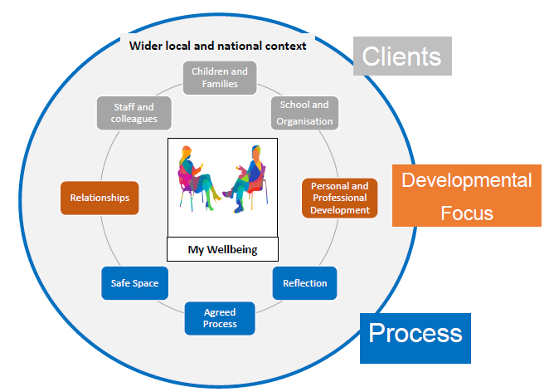

how can i access supervision?
Members of senior management teams in schools are invited to consider whether professional reflective supervision is a support they would like to engage with. This is a unique offer to teachers in Highland. Something that is not offered regularly in any other local authority in Scotland.

If you are interested in taking up this offer, an initial contact can be made with bernadette.cairns@highland.gov.uk, who will allocate a supervisor from within the Psychological Services to provide an initial 6 sessions (usually monthly).

The practitioner allocated as ‘Supervisor’ will then make contact with you and agree dates for supervision that are mutually convenient. Following the initial 6 sessions, practitioners can request to continue with this support, and this will be provided when capacity allows.

References:
- Hawkins, P. & Shohet, R. (2006). Supervision in the helping professions. Glasgow: Bell and Bain Ltd.
- Hawkins, P. & McMahon, A. (2020). Supervision in the helping professions (5thed). Open University Press.
- Lawrence, N. (2020). Supervision in education – Healthier schools for all. Barnardo’s Scotland report on the use of professional or reflective supervision in education.

